One Day Shipping

Design Document

Matt Ferrell - B00625174

Johna Latouf - B00698246

Orjan Monsen - B00697153

Robert Tracey - B00699803

*November 7th, 2016*

Table Contents

**Game Overview****2**

What is One Day Shipping? 2

Why This Game? 2

Where is This Game World? 2

Who do I control? 2

**Feature Set** **2**

General Features 2

Gameplay 3

**The Game World** **3**

Interactive Environment 3

Travel 4

Scale 4

Objects 4

Weather 4

Time 4

**Rendering System & Game Engine** **4**

Overview 4

Camera Control and Position 4

Collision Detection 4

Water 4

Lighting 5

**The World Layout****6**

Overview 6

**Game Characters****8**

Overview 8

Enemies 8

**User Interface****1**0

Overview 10

In-Game HUD 11

Cut Scenes 12

Title Screen 12

**Audio****1**2

Diegetic Sound 12

Non-Diegetic Sound 13

**Story****13**

Overview 13

Hours of Gameplay 14

Victory Conditions 14

**Appendix A: References****15**

**Appendix B: Rendering and Animation****16**

# Game Overview

## What is *One Day Shipping*?

*One Day Shipping* is an exciting arcade-style 3D platformer that blends the fast-paced action of games such as *Crazy Taxi* with the flexible platforming feel of the greatest 3D platforming games. You play as fledgling postal worker Larry Noodleman, on his first week of work, where you do battle with a rival postal company, avoid dangerous city obstacles, and deliver the mail in time. One caveat: Larry is cursed with awkwardly lanky limbs.

## Why This Game?

Fast-paced time trial arcade games have been a popular staple of the gaming industry since the advent of arcade gaming. This game looks to pay homage to the best aspects of this genre of game, while also adding in the charm of our cartoonish narrative. We believe that the right balance of comedy and speed will result in a highly enjoyable experience for our players.

## Where is This Game World?

The action of *One Day Shipping* takes place in the bustling metropolis of The City, a mountain city where people focus on their work and have no time for dalliance. In The City, there has always been a single mail provider: the dark and faceless corporation known as The Postal Service. But now a new company is threatening to take their business. That company is called One Day Shipping.

## Who do I control?

You play as Larry Noodleman. From birth, Larry has always had a set of awkwardly disproportionate and lanky limbs. Because of this, Larry has always had a difficulty at keeping a job. Now Larry is The City’s newest postal worker. As the player, you must guide Larry through the unpredictable world of the city, using his limbs to avoid obstacles and race to deliver each of his packages. The better you do, the more likely Larry will get to keep his job.

# Feature Set

## General Features

*One Day Shipping* controls in a 3D platforming style. It is an open world game where the entirety of the environment is available to the player from the first mission. In this world you can go anywhere, but the structure of the missions and locations of events will focus the player to certain regions per mission.

The game uses a low-poly art style for the environment. This art style allows us to display the world in a simple, clean manner that reflects the cartoonish quality of our narrative. It also makes the world look unthreatening, creating a juxtaposition between this friendly feel and the danger in the game.

## Gameplay

Each level takes place over the course of a single day, and the entirety of the game is broken up over the course of one work week. Challenges are added and built upon from one day to the next. Each day represents a new challenge which is dictated by the occurring narrative.

Every game day has a simple underlying task to complete: deliver the mail. Mail delivery is done in two steps:

### Collecting a package

The player heads to a point indicated by the HUD to receive a package from a delivery mailbox.

During this phase, objects that hit the player will not do damage. Instead, obstacles act to slow down the player movement, causing him to lose much needed momentum.

### Delivering a package

After a package is collected, the player must race to a new location on the map to deliver that package. The obstacles that originally only acted to slow the player before will now also cause damage to the current package. The player avoids this damage by keeping the package at a distance with his stretchy limbs.

If enough damage is done to a package, the package is destroyed and the player must return to the pickup location. If too many packages are destroyed, then the player is fired.

On each subsequent day, new challenges will be added to the gameplay, including new enemies, weather effects, and falling debris during the final level.

# The Game World

## Interactive Environment

*One Day Shipping* is a physics-based game, and therefore uses many physics colliders to push the character around the game world. In the suburban areas we have trampolines that allow the player to bounce over obstacles. Similarly, in the downtown core of the game world, puddles and oil slicks cause the character to slide out of control.

## Travel

*One Day Shipping* is an open world game that involves the player rushing from corner to corner of the city as fast as possible. Because of this, there are no waypoints in the game. Instead, the player begins each level at the central hub - the offices of the One Day Shipping delivery company.

The game environment is divided by a large river that the player can only cross by using one of three bridges. This divides the game world into noticeable sections that each have unique characteristics. If the player falls into the river, or any other body of water, his package is destroyed and he is respawned at the last package pickup location.

The player character is unique in his movement: he has disproportionately flexible and stretchable limbs that allow him to move around the environment quickly and dodge enemies. The player only moves on foot, and cannot utilize any other means of transportation.

## Scale

The physical world’s dimensions are 1000m x 582m, and the player character is 2m tall. We chose this scale because it is large enough that the player won’t feel boxed in, but small enough so that we can focus on small details to make the world look beautiful within the given time constraints.

## Objects

The world is populated by everyday objects you would find in a city. In the downtown area there are trash cans, stop lights, signs, benches, and billboards. Further into the suburbs you will find white picket fences, small bushes, and backyard trampolines. Each of these objects can either impede or advance the player’s movements.

## Weather

The weather is a game feature that will affect the gameplay mechanics of later levels in the game. The third level takes place during a large storm, and the sky is filled with thunderous rain and wind. We use the wind mechanic of Unity’s terrain tool to give a sense of blowing wind on foliage. We also create our own wind gizmo, that will both affect player movement and the movement of additional objects in the scene.

Weather conditions will noticeably affect the mood of the game as well. We will implement a Colorizing LUT screen effect to create a dreary appearance to our typically colourful world, and use a rain screenspace effect to cause streaks to flow down from the sky.

## Time

The player must deliver all packages assigned to them before time runs out. So in this way time is working against the player. Time is also a factor in the player’s score, the faster a player can complete a level the higher the score.

We have added managers to our game to affect the state of the current game rate. This allows us to pause the action.

# Rendering System & Game Engine

## Overview

This game is developed using the Unity3D environment. It is a fully-modeled 3D game that uses a mixture of low-poly environment assets and high-poly cartoonish characters. The contents of the game world are rendered in 3D, but all UI elements appear onscreen in 2D.

## Camera Control and Position

The game uses a simple third-person camera setup that always stays directly behind the player. The camera is slightly elevated in relation to the player and tilted downward so that the environment immediately in front of the player character is visible.

A screenspace shader for cutting through geometry is used on the camera to remove any forward-facing geometry that occludes the character. This only happens on geometry between the character and the camera.

## Collision Detection

All collision detection will be handled by Unity’s PhysX engine. Environment objects will mostly use mesh colliders since the low-poly assets make for relatively simple collider meshes.

Physic materials will also be applied to several game objects to affect the way they force the character to move. This includes our water, oil slicks, and trampolines.

## Water

The water areas that define the game world will be manipulated using a simple water shader that registers both wind direction from our wind gizmo, as well as texture data from a flow map texture.

## Lighting

The game uses simple environment lighting. Many of the environment materials use the standard specular light model, with full smoothness applied.

The scene is created with a procedural skybox. It uses a single directional light as the sun. This light is set to ‘mixed’ and will affect both static and dynamic objects.

The skybox provides the ambient light colour for the scene. The skybox is fixed, and will not change throughout the course of a level, due to the fact that all static objects in the game are baked with a lightmap. This is due to the size of our environment, and the want for smooth gameplay performance.

# The World Layout

## Overview

The world of The City consists of three main regions separated by a river. The northwest portion of the world is the downtown core, populated with skyscraper buildings and stores.

To the northeast are the suburbs, where the city workers live. The area is dense with homes, backyards, and nature. Finally, the southern area of the city is a plateau where the offices of the evil Postal Service resides.

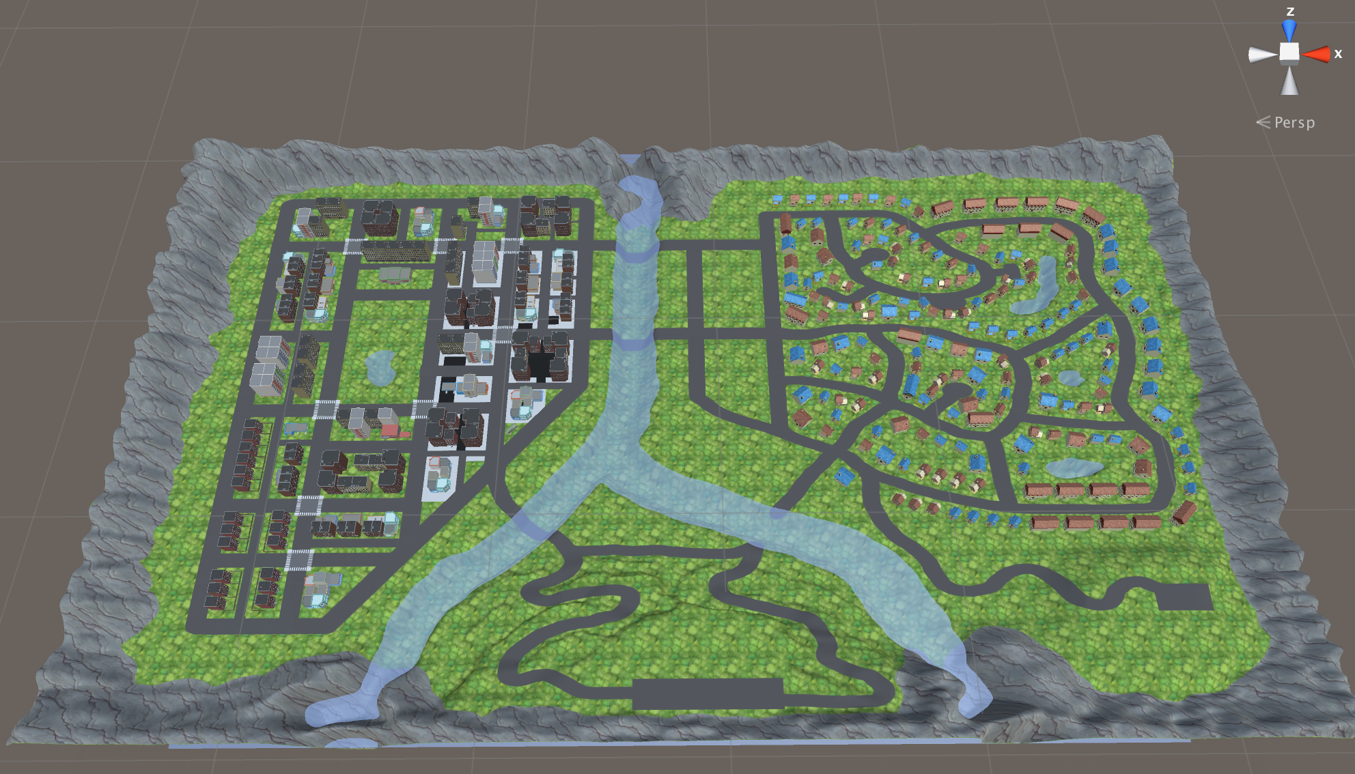

Figure 1: Overview Of Game World

### The Downtown Core

The downtown area consists of tall buildings, restaurants, stores, and offices. At the centre of the city is a large green park. North of the park is town hall, and south of the park is the office of One Day Shipping. This is where the player starts, and must compete with moving cars and dogs.

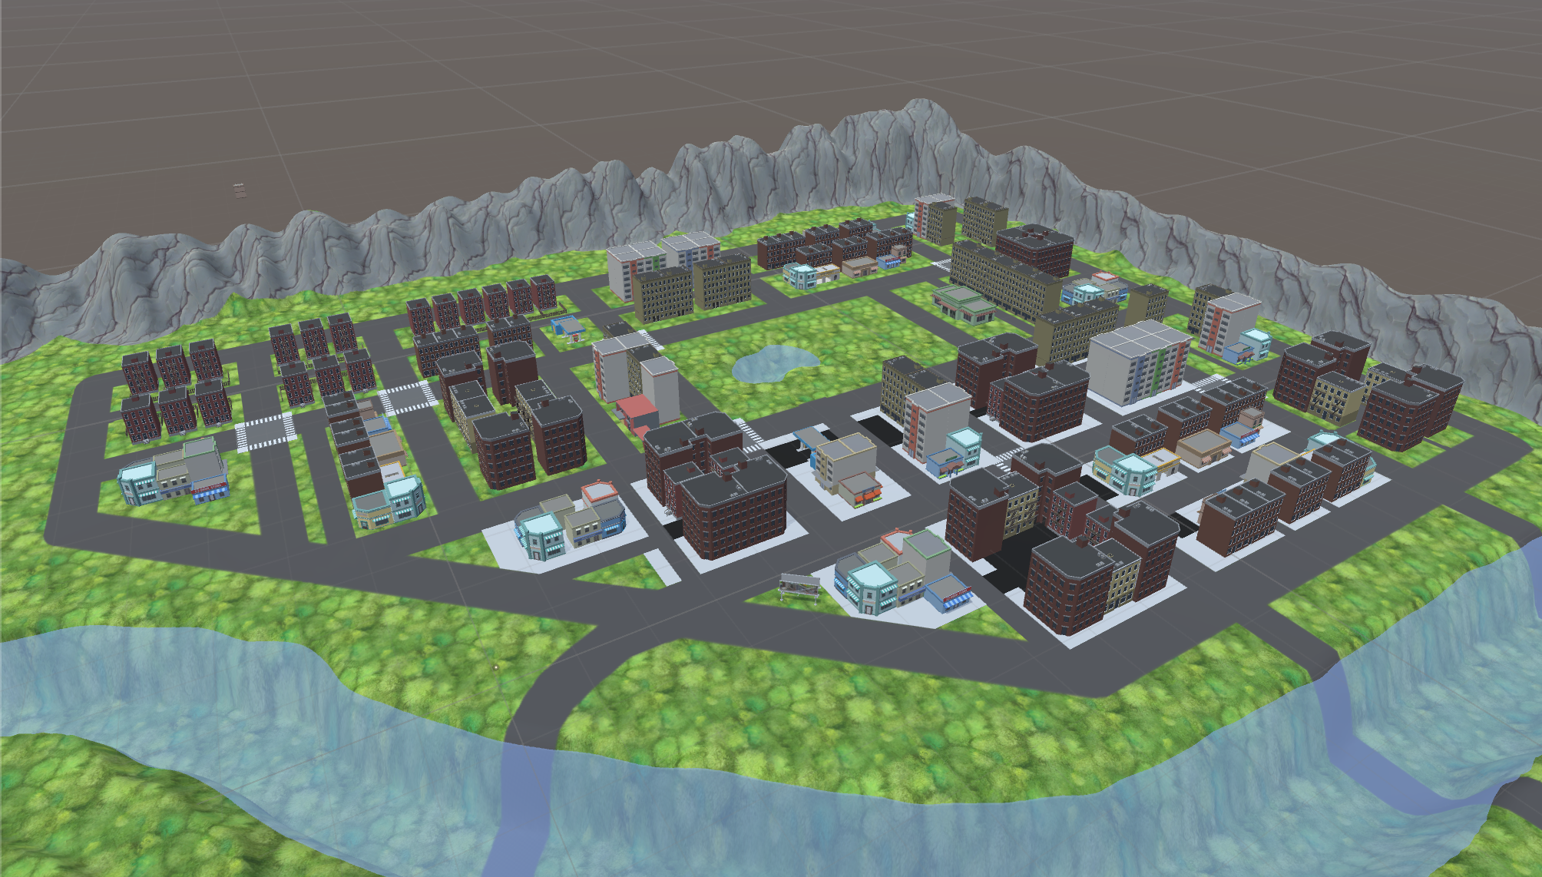

Figure 2: The Downtown Core

### The Suburbs

The suburban area is a rather large series of neighbourhoods consisting of different types of houses and apartments. There are a few lakes within the suburbs, as well as trees, parks, schools, grocery shops, and gas stations. In the lower southwest corner of the suburbs (next to the river) there is a green park. In the southeast area there is a forest and hiking area with a parking lot.

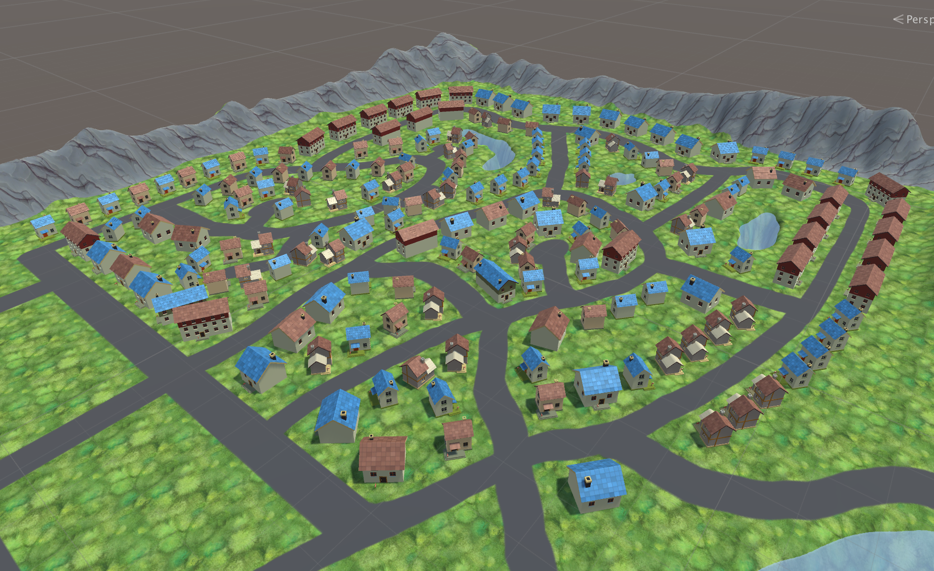

Figure 3: The Suburbs

### The Plateau

On the southern side of the river lies the evil Postal Services office, looming over the entire city. There are winding roads going up to the office on both sides of the mountain, and at the top is a large parking lot. Postal workers will protect the plateau from unwanted intruders.

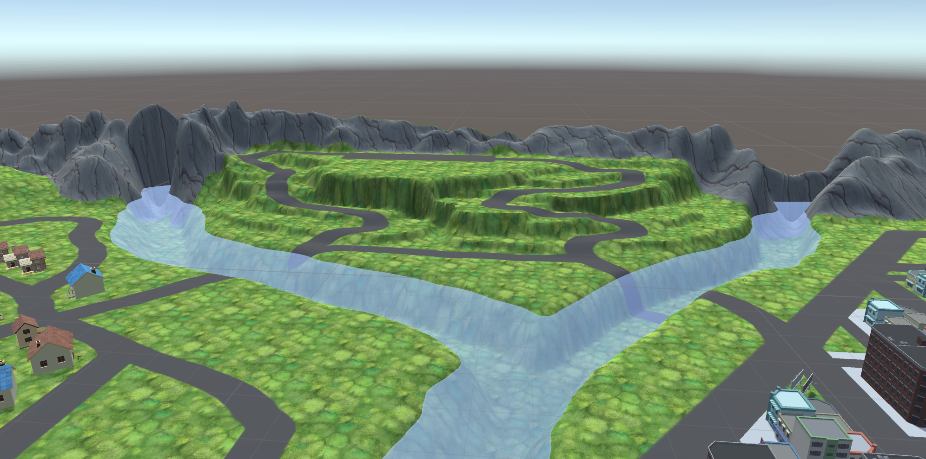

Figure 4: The Plateau

# 

# Game Characters

## Overview

*One Day Shipping* is populated by cartoonish humans and animals. The player character, Larry Noodleman, is a lanky delivery man capable of stretching his limbs and engaging in acrobatics to complete his tasks.

Apart from the player, other characters fill the offices of the One Day Shipping delivery company. The Boss, the owner of One Day Shipping and Noodleman’s employer, is a gruff loud-mouth who barks orders in cut scenes. The Dispatcher is a raspy, middle-aged woman providing Noodleman with information and directions.

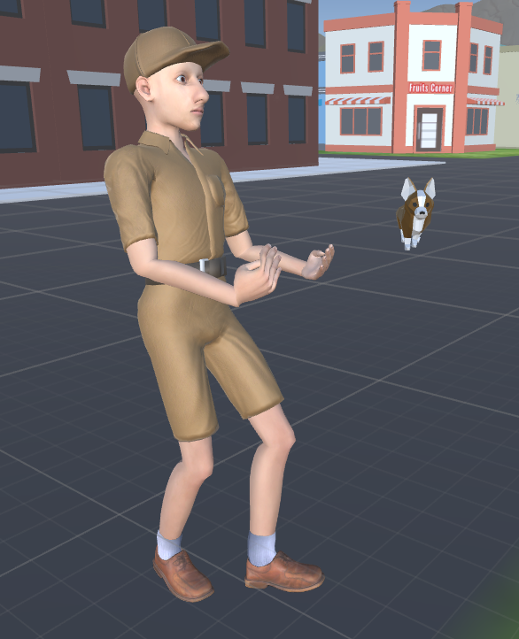

Figure 5: Larry Noodleman Model

## Enemies

### Ferocious Dogs

Dogs are minor enemies that cannot be destroyed. They run randomly within a set boundary until the player enters that area. Dogs chase Noodleman, standing in front of him, running circles around him, and causing damage to his parcels. Dogs are equipped with a large box collider to slow Noodleman down.

The corgi was chosen as our ferocious dog, as it looks innocent and nonthreatening. The low-poly corgi model is sourced from Blendswap, created by user Ishigoemon (Appendix A-1), and the rig and animations are from the Unity Asset Store’s Golden Tiger, created by Zelous Interactive (Appendix A-2).

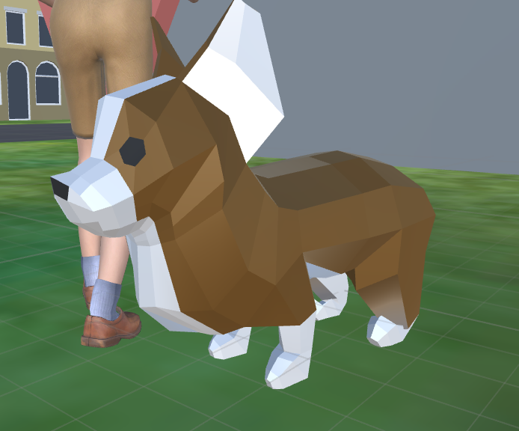

Figure 6: The Ferocious Dog

### Postal Workers

The evil postal workers are modelled using Make Human (Appendix A-3) and blender (Appendix A-4), and animated with Mixamo (Appendix A-5). The postal workers appear on the second day of the One Day Shipping story. Similar to the dog enemies, postal workers interfere with Noodleman’s deliveries by getting in his way and damaging his packages. As the story progresses, postal workers become more aggressive and they form an army intent on stopping Noodleman at all costs. Each postal worker has a designated path in the city and is configured to follow and attack Noodleman when he is seen.

The model for the postal worker is noticeably taller than Noodleman, giving a sense of strength in comparison to our character. As the game progresses, postal workers throw packages and letters from their bag to further damage the player’s parcel. These objects are also physical obstacles.

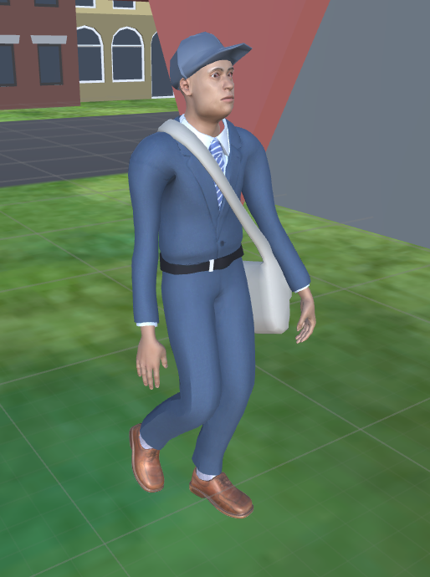

Figure 7: Enemy Postal Worker

### Cars

The game world is a bustling city, and such the roads are filled with buses, cars, delivery vans, and other vehicles that race around the area with little care.

Each vehicle is given a pathway, using a Unity plugin called iTween (Appendix A-3). The vehicles will speed and swerve around corners with disregard for the player. If Noodleman is hit, he will be sent flying. A skilled player can use these collision physics to get closer to their target destination.

# User Interface

## Overview

There are three main user interface modes in the game: The in-game Heads Up Display (HUD), the cutscene conversation screens, and the start menu. The style is minimal and colourful, reflecting the game’s colour palette.



Figure 8: Spork Font for UI

The following sections contain wireframes of the UI. Each element of the UI will use a font called Spork.

## In-Game HUD

## HUD.jpg

Figure 9: UI HUD Wireframe

This interface is displayed during gameplay. A mini-map and arrow graphic indicate where the player must go to finish a delivery. The mini map contains an overview of the game world relative to the player’s location, and will not display the entire world at any time.

A timer is displayed in large font in the top center section of the screen. It counts down based on the time remaining of the current work day, and will turn red when the time is nearly up.

Basic stats are displayed in the upper left corner, including a score counter and the number of packages that can be destroyed before the level is failed.

Package status information is displayed to the right. This includes the number of packages that have been successfully delivered, and how many packages remain. This information is displayed as a fraction.

Package health is tracked using a progress bar in the lower left. The progress bar is based on Unity’s UI slider component with minor modifications. The package health bar is only displayed when a character is holding the package for delivery.

The in-game UI also includes a pause menu that will allow the user to resume a mission or quit to the main menu.

## Cut Scenes

## CutScene.jpg

Figure 10: Cutscene UI Wireframe

Cut scenes display dialog between Noodleman and the other characters in the game, and appear at intermissions or as an overlay during missions.

Game characters appear on screen when they are speaking and dialog is presented as text in speech bubbles at the bottom of the screen. The user has the option to skip these scenes or continue to the next section of dialogue. The cutscene text is stored in ‘event’ scriptable objects and handled by an event manager script. They are triggered from the event manager, which also handles the triggering of in-game sequences.

## Title Screen

This screen is dominated by a title graphic with a button to begin the game. Additional menus include a level selection screen, a list of controls, and an area that displays high scores per level.

# Audio

## Diegetic Sound

The game world of *One Day Shipping* is meant to be lively and cartoonish, so the environment produces large, loud, slapstick sounds that are comparable to that game feel.

The collision sounds are accentuated with large punches and musical stings. This audio is directional, coming directly from the source of the collision. Passing cars in the environment will make loud revving sounds, and some will even have bassy sound systems.

In the forested areas of the suburbs, there are the bird sounds and rustling. As you approach the game’s large river, you will also hear the sound of running water.

During cutscenes, the main characters will have dialogue stings associated with their speech bubbles and images. These stings will help give texture to the characters, and provide a relatable voice to each.

## Non-Diegetic Sound

The will have a musical underscore that will change depending on the level. The speed of the score will increase as the clock begins to tick down, creating urgency in the player.

Additionally, audio will be assigned to in-game UI elements to increase the responsive feel of selecting and traversing through our menus.

# Story

## Overview

*One Day Shipping* is a narrative-driven game. The content of the narrative is meant to both explain the current changes in gameplay per level, as well as make the player feel relatable connections with the workers at the One Day Shipping delivery company.

Story

Larry Noodleman is a new hire at the startup One Day Shipping delivery company. The One Day Shipping delivery company, run by the loud-mouthed Boss, is a brand new postal service provider that guarantees package delivery time of one day or less.

The story begins on Larry’s first day at work. Larry has a history of losing jobs, and is eager to impress his boss by meeting the delivery standards. The only other delivery service in The City is the shady Postal Service; a large faceless corporation that has monopolized on all business in the area. They are generally known as being slow and inefficient with their package deliveries, but have also stamped out any aspiring companies from challenging them. But the people cry out for faster delivery services, and the Boss has listened.

Larry is not like every other human. He was born with extremely hypermobile joints in his arms and legs, and has been struggling with his lankiness his entire life. However, the hypermobility has made Larry a fast traveler, and the Boss saw him as an incredibly talented delivery person due to his traveling speed.

The game is centered around Larry’s first five days of work. On the first day, the Boss has given Larry some rather easy tasks; the area of delivery is restricted to the downtown core only. The Boss is not entirely sure yet if he can promise one day delivery to the suburban area, and wants to see how Larry handles the city first. Larry hates being hit by annoying cars and attacked by aggressive street dogs, which damage his packages and results in less happy customers. He looks to avoid the cars and dogs at all cost.

On the second day of work, the Boss has realized Larry’s true delivery talents, and hence opened the delivery area to the suburbs as well. Also, the Dispatcher has received a threatening letter from the Postal Service saying there will be postal service agents sabotaging Larry’s deliveries.

On the third day of work the city is being hit by a brutal storm. The winds are strong and the rain creates slippery roads, but nothing will stop Larry from staying true to the one day package delivery promise. It is extra challenging to deliver the packages under these weather circumstances, but Larry steps up his game and seizes the opportunity to impress the Boss even more. One Day Shipping is the only company open, and the mayor tasks them with delivering relief umbrellas to needy citizens.

The next day, the storm has settled down, the rain has stopped, and the roads have dried up. The city’s inhabitants are very impressed with the work One Day Shipping has done for the city, which has created a big media buzz and lots of extra attention for the company. Simultaneously, The Postal Service's reputation has drastically gone down, and they are not happy about this. The Postal Services starts a violent street war. They seek to destroy Larry and One Day Shipping in order to get back in control of package delivery in The City.

There are armies of Postal Service agents in the streets targeting Larry, but Larry must still deliver packages and does not have time to fight back. Meanwhile, since the Postal Service focus all their resources on taking down Larry, they forget to deliver a single package, and therefore lose all their reputation within the community.

On the fifth day, after the Postal Services fails to destroy Larry and One Day Shipping, they implement their scorched earth tactic and begin to rain flaming packages from the sky. The apocalypse is here, but Larry has to stay true to his job and deliver those packages.

## Hours of Gameplay

The game revolves around time (how fast the player completes the levels) and high scores, meaning that it has a good level of replayability. Players will replay levels to beat their original scores, getting higher scores by delivering packages faster and avoiding more obstacles.

## Victory Conditions

The player wins the game by completing all five levels. At the end of each level, the player receives a high score based on how fast the levels were completed, and how much damage has been done the the packages that were delivered.

# **Appendix A: References**

1. **Low-Poly Corgi:** http://www.blendswap.com/blends/view/79709
2. **Tiger Asset:** https://www.assetstore.unity3d.com/en/#!/content/55797
3. **Make Human:** http://www.makehuman.org/
4. **Blender:** https://www.blender.org/
5. **Mixamo:** https://www.mixamo.com/
6. **iTween**: http://itween.pixelplacement.com/index.php

# 

# 

# **Appendix B: Rendering and Animation**

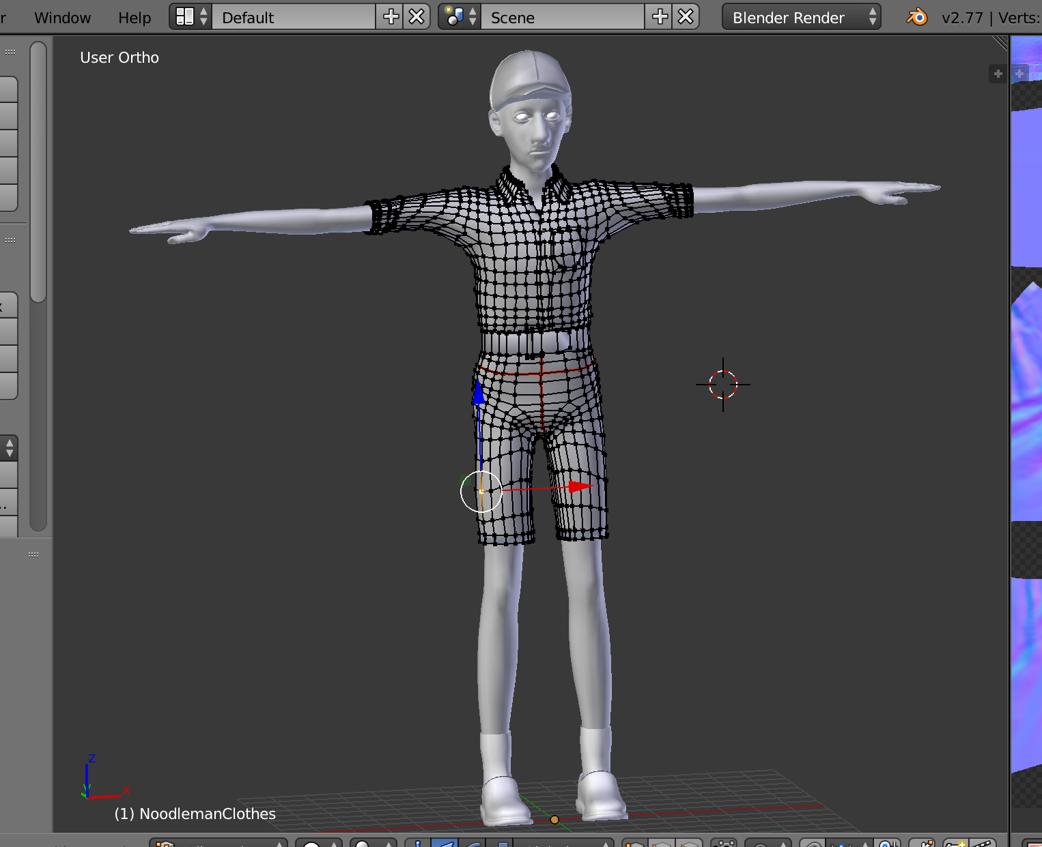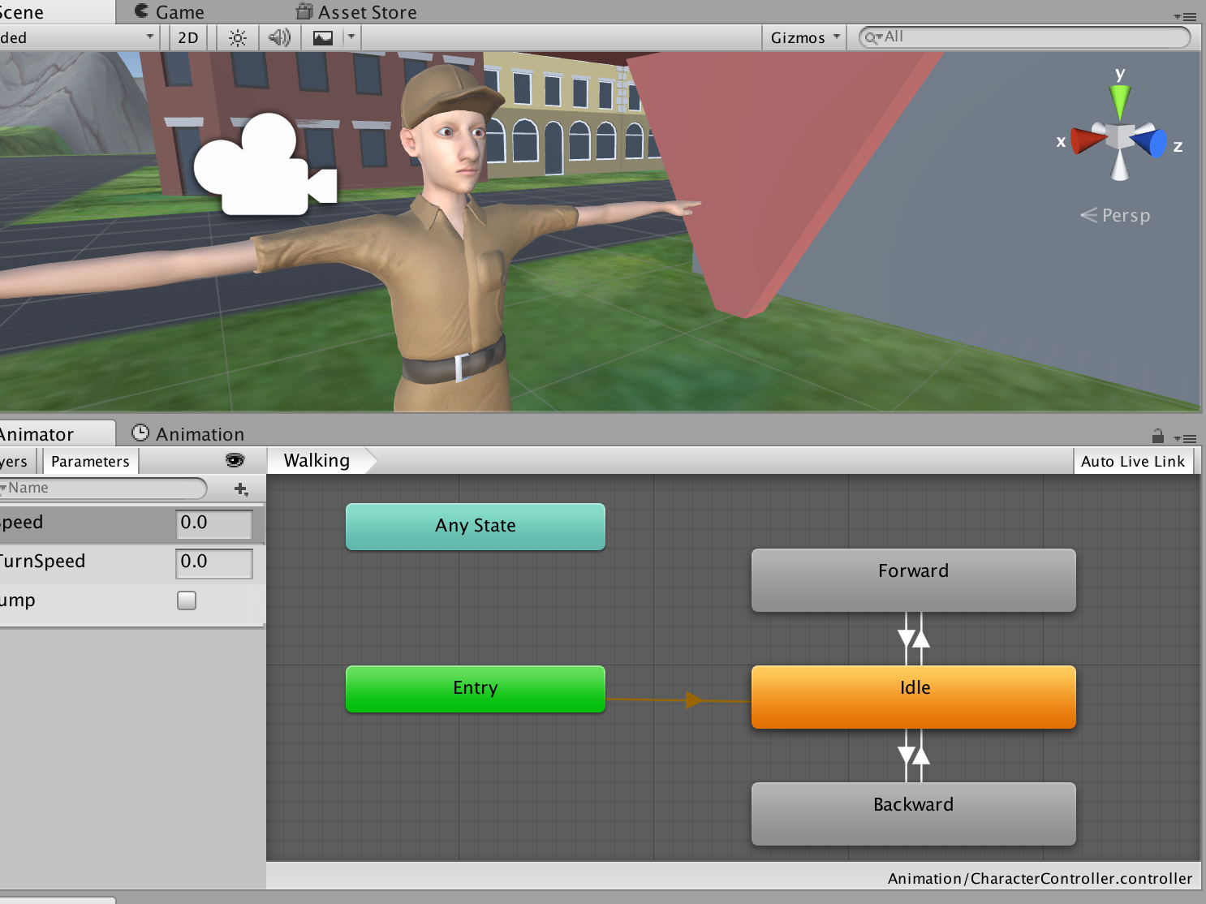

B-1: Noodleman model and animation controller

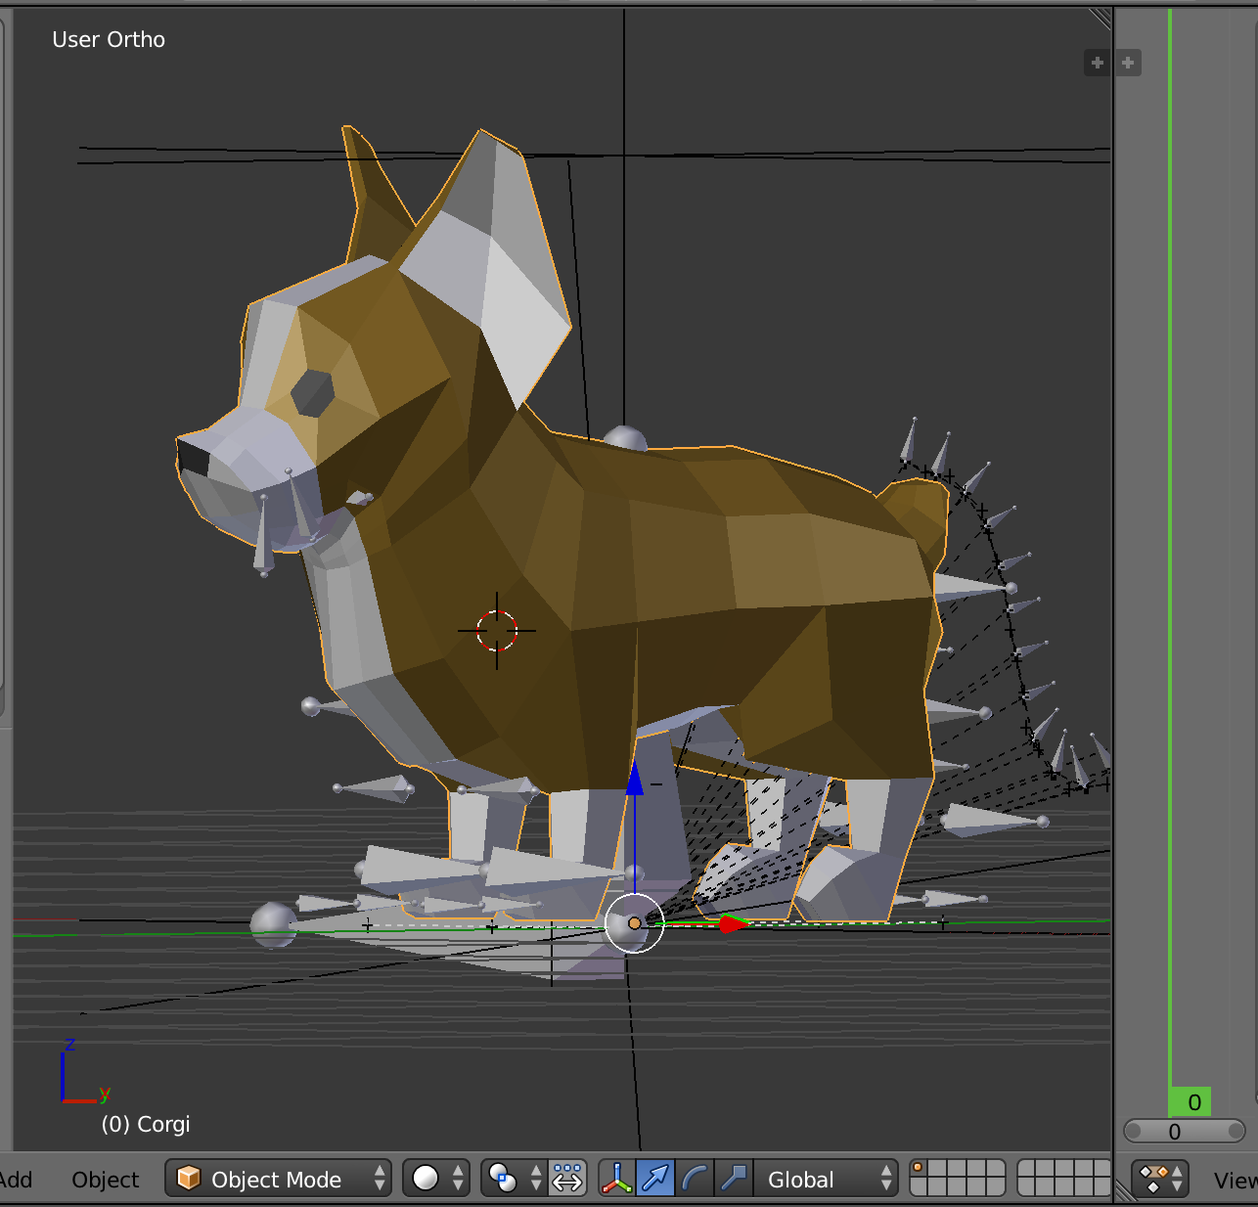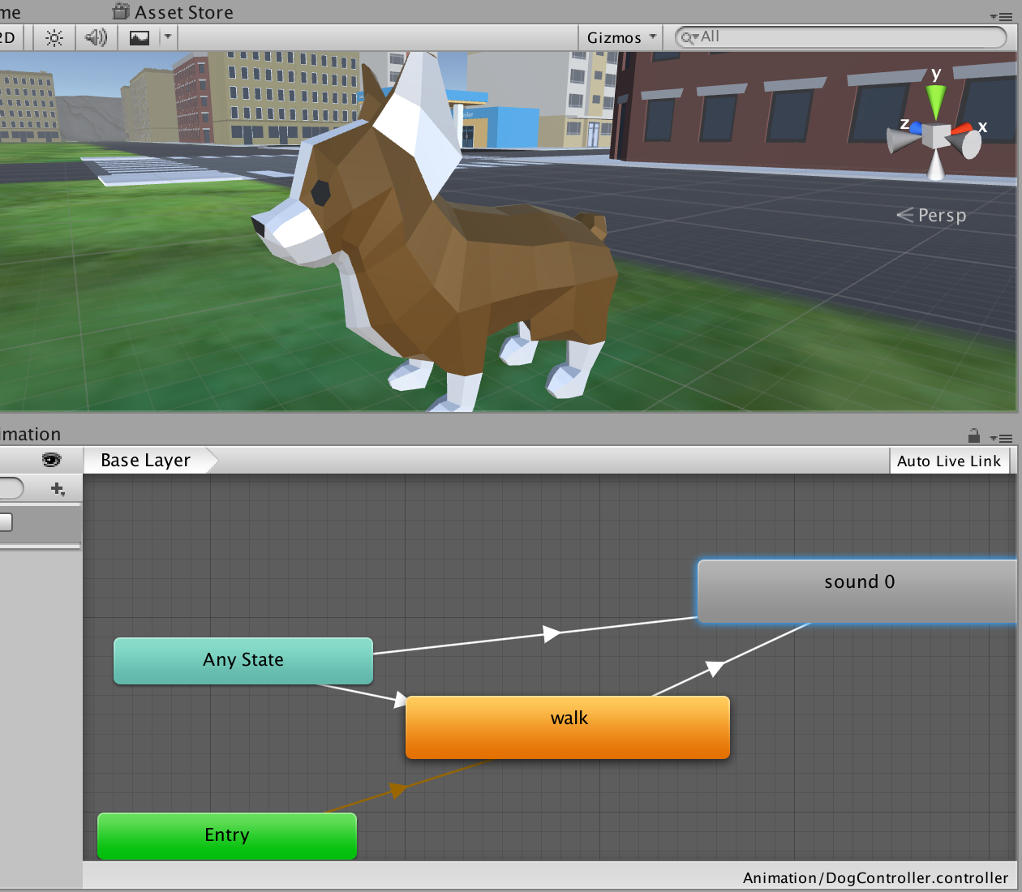

B-2: Dog rig taken from Unity Asset Store and animation controller, model from Blendswap

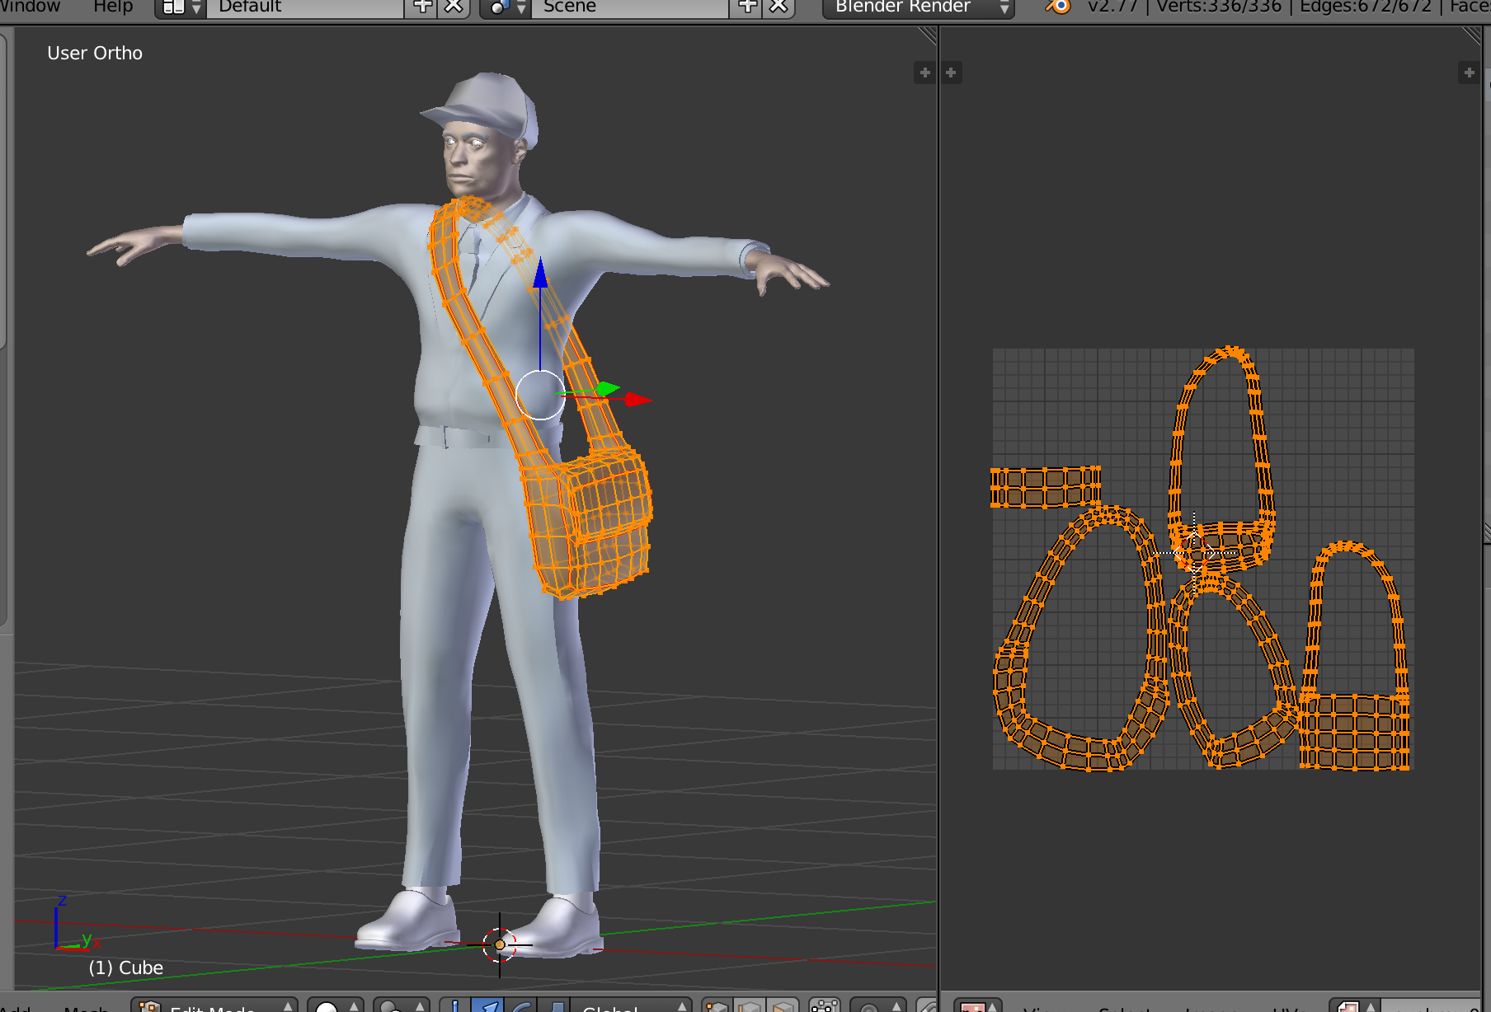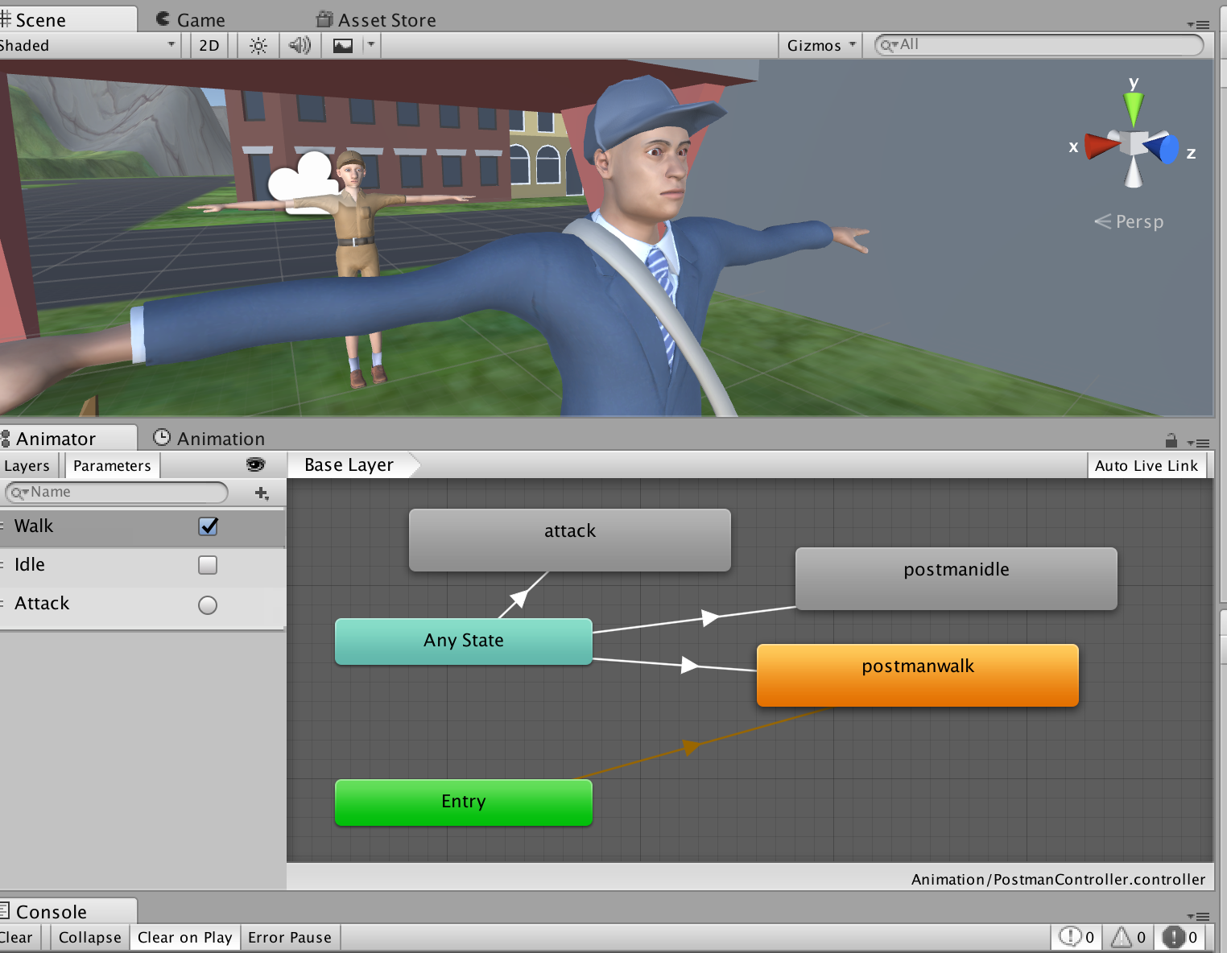

B-3: Postal Worker model and animation controller